Some ideas to help save you money & reduce your foreign exchange risk:

Have a plan. Review your foreign currency requirements and circumstances regularly to develop a payment strategy accordingly. Find a service partner that can help.

Settling invoices with overseas vendors in their local currency. Overseas vendors often inflate invoices in order to mitigate possible currency risk. Dealing in their local currency allows you an opportunity to negotiate a discount.

Foreign currency accounts. Great if you have payments and receipts in a particular currency as it reduces the need for multiple cross currency transfers but can be expensive to manage with high fees attached.

Use online transfers. Very cost effective. They provide easy cash management and increases payment visibility

Spot payments. Using a spot payment means buying or selling currency at the current exchange rate. Look for providers with low fees and consistently competitive spreads between the buy and sell rates.

Hedge with a forward exchange contract. A forward contract allows you to buy now at an agreed exchange rate but pay later. These are ideal for protecting against fluctuations and are useful for budgeting as the exchange rate on a future money transfer is secured in advance.

Limit Orders. Limit orders are an instruction to purchase a currency when the rate hits a predetermined target. It’s very effective for businesses with some time flexibility before they need to make their payments and negates the need to watch exchange rates day and night!

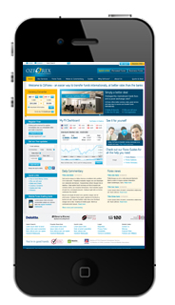

Mobile Tools (download free here)

